Full Name of Student:
Year:
Holy Communion students learning status check list
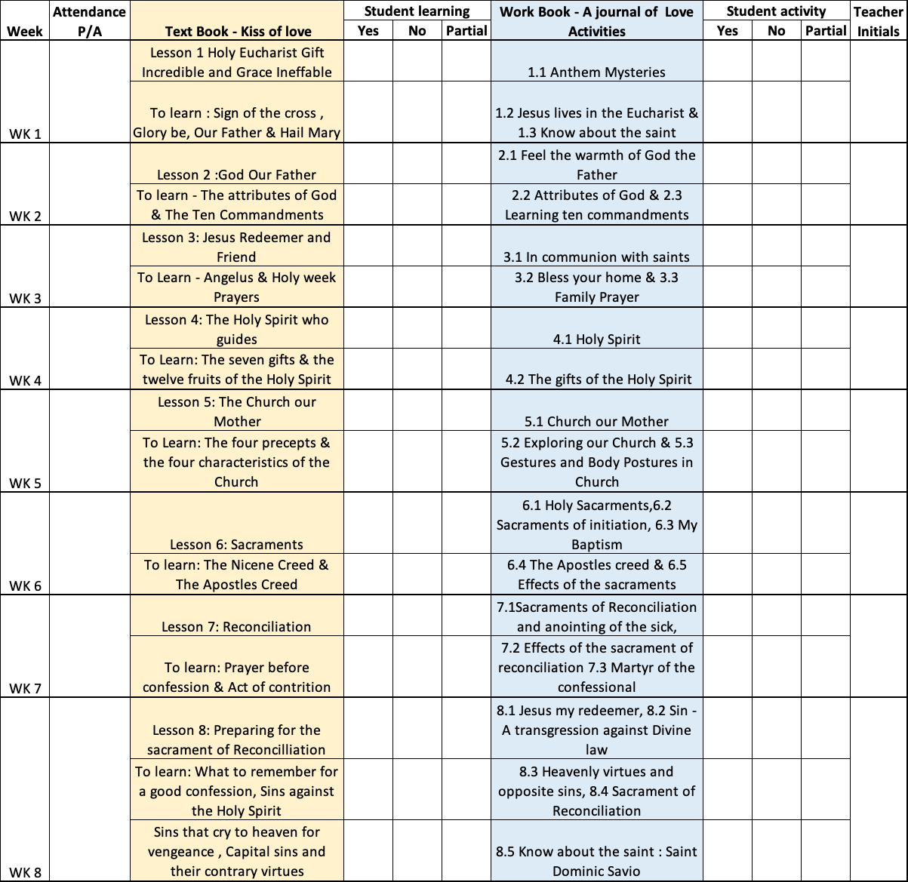

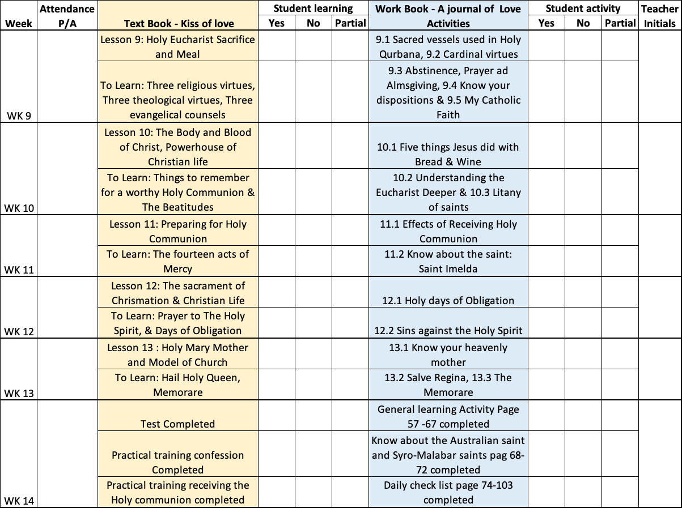

Students Additional learnings if any:

This document is prepared based on --------------------------------------------- (Full Name of Student) 's participation in the Holy communion and confession preparation training course conducted by ---------------------------------------------------------------------------------------------( Name of your parish) in the year -----------------------------------(Year)

Teacher in Charge:
Signature: Date:

